CONTRACT AGREEMENT
For Installation of Iron Grill Enclosures
GAIL Gas Infrastructure – South City Apartments
Dated: 27th February 2026

1. PARTIES TO THIS AGREEMENT
This Contract Agreement (hereinafter referred to as the "Agreement") is entered into on 27th February 2026, by and between:
PARTY A — CONTRACTOR:
Chinnaraju V, a contractor duly engaged by GAIL Gas for execution of piped natural gas infrastructure works, bearing mobile number +91 89712 21397, hereinafter referred to as the "Contractor" is being requested to carry out this work for Gail Gas subscribers. This activity falls under the subscriber responsibility and is not covered by GAIL Gas.
PARTY B — SUBSCRIBERS:
All residents and flat owners (hereinafter referred to as the "Subscribers") of South City Apartments, whose names and details are duly recorded in the official Subscriber List maintained separately and forming part of this Agreement.
AUTHORIZED OVERSEEING GAIL & South City Property Management REPRESENTATIVE:
Nikunj, GAIL Gas Authorized Personnel, who has reviewed and approved the design specifications for the iron grill enclosures described herein, acting on behalf of GAIL Gas Operations and Maintenance.
South City Property Management Office, Brightstone (JLL) represented by Nagendra BS

2. SCOPE OF WORK
The Contractor agrees to design, fabricate, and install iron grill enclosures required to secure all 18 blocks of South City Apartments as per the design guidelines provided by the GAIL Gas, reviewed by Authorized Personnel (Nikunj) and the Contractor. The design of the grills shared by the Contractor has been shared with GAIL Gas officials as well as with the South City Maintenance & property management office. This is being provided to the Contractor to ensure no alignment issues in terms of adhering to the GAIL guidelines occur. The scope of work shall include:
(a) Fabrication and installation of iron grill enclosures at designated GAIL Gas meter/connection points for each of the 18 blocks, as per block-wise dimensions specified in Schedule A of this Agreement. This comes to 17 grill boxes.
(b) Each enclosure shall be fitted with a lock-and-key mechanism operable by authorized GAIL Gas Operations & Maintenance staff and/or the Property Management Office staff, to enable safe and prompt access during routine maintenance, inspection, or emergency activities.
(c) Minimum two (2) sets of keys shall be provided per enclosure — one set to the GAIL Gas O&M team and one set to the Property Management Office.
(d) All materials used shall be of MS (Mild Steel) iron of appropriate gauge, adequately treated with anti-rust primer and paint, conforming to quality standards acceptable to GAIL Gas.
(e) All installation activities shall be carried out with minimal disruption to residents and in adherence to GAIL Gas safety guidelines, shared by GAIL below.

3. TIMELINE FOR COMPLETION
The Contractor shall complete all fabrication and installation activities across all 18 blocks of South City Apartments by 4th March 2026. Any delay beyond this date shall be communicated in writing to the GAIL Gas subscribers Subscribers with reasons, and a revised schedule shall be mutually agreed upon.

4. FINANCIAL TERMS
Contribution Per Subscriber to be paid by the subscriber to the Contractor by 28th Feb 2026 | Rs. 450/- (Rupees Four Hundred Fifty Only)
Total cost being collected by the contractor | Rs. 3,50,000/- (Rupees Three Lakh Fifty Thousand Only)
Number of Blocks | 18 Blocks – South City Apartments, requiring 17 grill boxes.
Completion Deadline | 4th March 2026
4.1 Each Subscriber shall contribute Rs. 450/- (Rupees Four Hundred Fifty Only) towards the cost of design, fabrication, and installation of the iron grill enclosure.
4.2 The total contract value is Rs. 3,50,000/- (Rupees Three Lakh Fifty Thousand Only) encompassing all 18 blocks as per the approved design specifications reviewed by Nikunj (GAIL Gas Authorized Personnel) and the Contractor.
4.3 The Contractor shall collect Rs. 450/- from each Subscriber and maintain an accurate and transparent Subscriber List including name, flat/block number, amount received, and date of collection with Signature of the Subscriber.
4.4 In the event that the total amount collected from all Subscribers exceeds the actual total expenditure upon completion of all installation activities across all 18 blocks, the excess amount shall be calculated, assessed transparently, and refunded/distributed back to all Subscribers on an equitable and proportionate basis.
4.5 No additional charges shall be levied on Subscribers beyond Rs. 450/- per subscriber unless mutually agreed upon in writing by all parties. Standard Gail costs and work required to be done in individual Subscriber residence to facilitate gail gas pipe ie core cutting, slab cutting etc are individual Subscriber decision and will be at actuals and not covered by this Contract

5. OBLIGATIONS OF THE CONTRACTOR
5.1 Complete all fabrication and installation work in a professional and workmanlike manner, conforming to the approved design.
5.2 Ensure all enclosures are installed by the completion deadline of 4th March 2026.
5.3 Maintain a complete and accurate Subscriber List of all collections, available for inspection upon request.
5.4 Provide minimum two (2) functional key sets per enclosure to GAIL Gas O&M and Property Management Office upon completion.
5.5 Rectify any defects in material or workmanship identified within 90 days of installation at no additional cost.
5.6 Provide a final expenditure statement to Subscribers and GAIL Gas personnel upon completion, enabling transparent calculation and distribution of any excess amounts.
5.7 Provide daily subscriber collection report of Rs 450 for this activity.

6. OBLIGATIONS OF SUBSCRIBERS
6.1 Pay the agreed contribution of Rs. 450/- per subscriber in a timely manner as communicated by the Contractor.
6.2 South City Association to the contractor and will be a 9am to 6pm community work Provide reasonable access to relevant areas for installation activities upon prior notice.
6.3 Not tamper with, damage, or modify the installed iron grill enclosures our any GAIL Gas equipment or pipeline in any manner.

7. ACCESS & OPERATIONAL AUTHORITY
The iron grill enclosures installed under this Agreement shall at all times remain accessible to:
(a) GAIL Gas Operations & Maintenance (O&M) Team — for routine maintenance, meter reading, inspection, valve operation, or emergency response.
(b) Property Management Office staff of South City Apartments — for emergency access or coordination with GAIL Gas teams.
Subscribers shall not restrict or impede access to the enclosures by the above authorized personnel. These grill enclosures are being fabricated to be installed at the base of each cluster/Bock where the pipeline merges via the service regulator into the main underground supply line

8. DISPUTE RESOLUTION & GOVERNING LAW
8.1 Any disputes arising out of or in connection with this Agreement shall first be resolved through mutual discussion and mediation between the parties.
8.2 If unresolved, disputes shall be referred to the GAIL Gas Authorized Personnel (Nikunj) and/or the Property Management Office of South City Apartments for final resolution.
8.3 This Agreement shall be governed by the laws of India.

SCHEDULE A
Approved Iron Grill Enclosure Design Specifications
South City Apartments – All 18 Blocks | Depth: 8 inches uniform across all enclosures
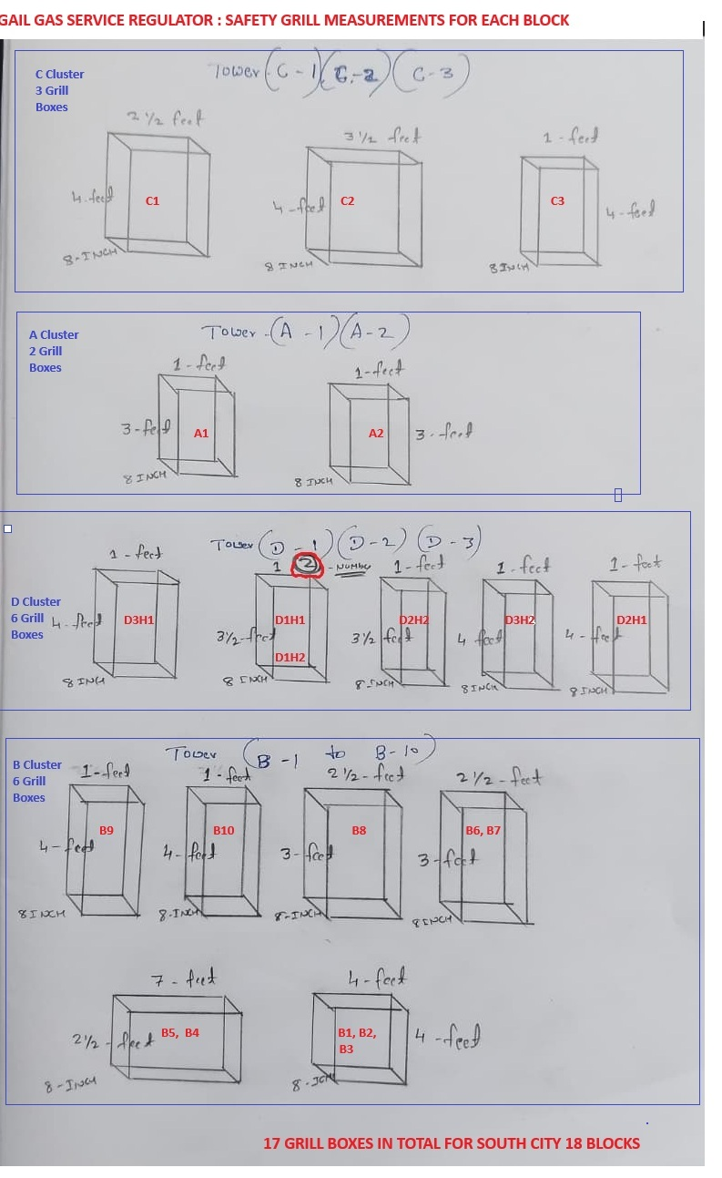
Notes:
1. All dimensions are as per the hand-drawn design sketch reviewed and approved by Nikunj (GAIL Gas Authorized Personnel) and Chinnaraju V (Contractor) prior to signing of this Agreement.
2. Depth is uniform at 8 inches for all enclosures across all towers/blocks.
3. Where multiple enclosure types are listed for a block group (e.g. B-1 to B-10), the quantities per type shall be as per the actual site requirement confirmed by the Contractor and GAIL Gas representative.
4. The original hand-drawn design sketch signed by both parties shall be retained as a physical annexure to this Agreement.
Email from GAIL with Specifications
From: Smaran.M <smaran.m@gmail.com>
Date: Fri, Feb 27, 2026 at 11:37 AM
Subject: Re: Fw: Intimation regarding MDPE connectivity of L&T south city apartment & availability of PNG inside the apartment.
To: Tapan Shukla (तपन शुक्ला) <tapan.shukla@gail.co.in>
Cc: SCMC SOUTH CITY MAINTENANCE COMMITTEE <scmcee@gmail.com>, <Itadmin@sugruha.in>, President, SUGRUHA <president@sugruha.in>, Secretary, SUGRUHA <secretary@sugruha.in>, nagendra.bs@jll.com <Nagendra.BS@jll.com>, Ravi Tandle (रवि तांडले) <ravi.tandle@gail.co.in>, Anand Prakash (आनन्‍द प्रकाश) <aprakash@gail.co.in>, Abhishek KG <abhishek.resonance06@gmail.com> <abhishek.resonance06@gmail.com>, <rcm.bengaluru3@energyworld.biz>, Praveenyadavgpt@gmail.com <praveenyadavgpt@gmail.com>, bhavardhan m <bhavardhanmv@gmail.com>, SURENDRA BABU NAIK BANAVATHU (सुरेंद्र बाबू नाइक बनवथु) <surendrababu@gail.co.in>, Dharmendra Kumar (धर्मेंद्र कुमार) <dharmendra@gail.co.in>, chinnarajuv1992@gmail.com <chinnarajuv1992@gmail.com>
Dear Tapan ji
Kindly see the attached drawing for the grill work being fabricated by Chinnaraju the Gail gas contractor for underground lines. This will be paid for directly by subscribers to the GAIL contractor.
The drawings have been submitted by Chinnaraju. Copying him for sync up
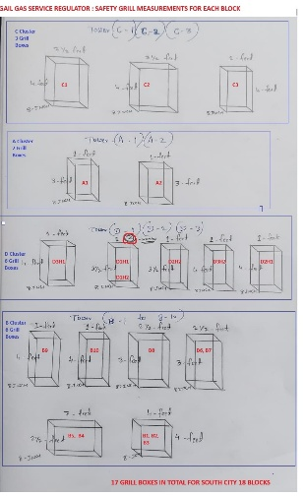
Regards
Smaran Mudbidri
97399 81450
For South City, Sugruha
---------- Forwarded message ---------
From: Tapan Shukla (तपन शुक्ला) <tapan.shukla@gail.co.in>
Date: Fri, Feb 27, 2026 at 11:17 AM
Subject: Fw: Intimation regarding MDPE connectivity of L&T south city apartment & availability of PNG inside the apartment.
To: scmcee@gmail.com <scmcee@gmail.com>, Itadmin@sugruha.in <Itadmin@sugruha.in>, Smaran.m@gmail.com <Smaran.m@gmail.com>
Cc: president@sugruha.in <president@sugruha.in>, secretary@sugruha.in <secretary@sugruha.in>, nagendra.bs@jll.com <Nagendra.BS@jll.com>, Ravi Tandle (रवि तांडले) <ravi.tandle@gail.co.in>, Anand Prakash (आनन्‍द प्रकाश) <aprakash@gail.co.in>, Abhishek KG <abhishek.resonance06@gmail.com> <abhishek.resonance06@gmail.com>, rcm.bengaluru3@energyworld.biz <rcm.bengaluru3@energyworld.biz>, Praveenyadavgpt@gmail.com <praveenyadavgpt@gmail.com>, bhavardhanmv@gmail.com <bhavardhanmv@gmail.com>, SURENDRA BABU NAIK BANAVATHU (सुरेंद्र बाबू नाइक बनवथु) <surendrababu@gail.co.in>, Dharmendra Kumar (धर्मेंद्र कुमार) <dharmendra@gail.co.in>
Dear Sir,
After installation of service regulator at site it is requested to provide safety fencing around SR location with canopy & fire extinguisher at your end to ensure safety of SR & avoid external tampering. Site snap has been attached herewith for your reference. Kindly ensure that:
>Ample ventilation should be available throughout the meshes.
>Ample space for maintenance must be available to ensure future maintenance needs. May Pls maintain minimum gap of 500 mm from the pipes in all the dimensions
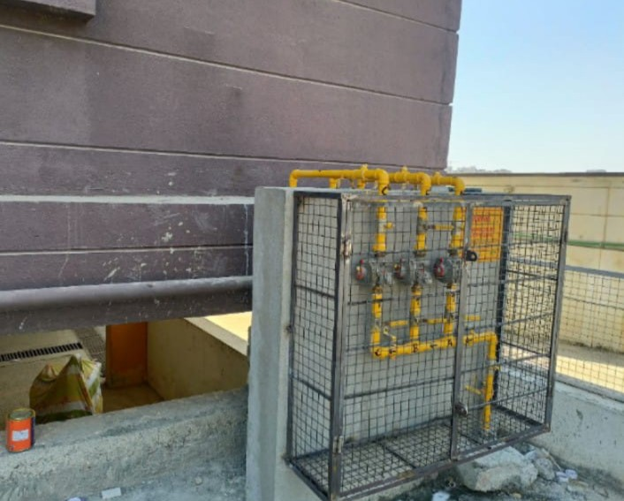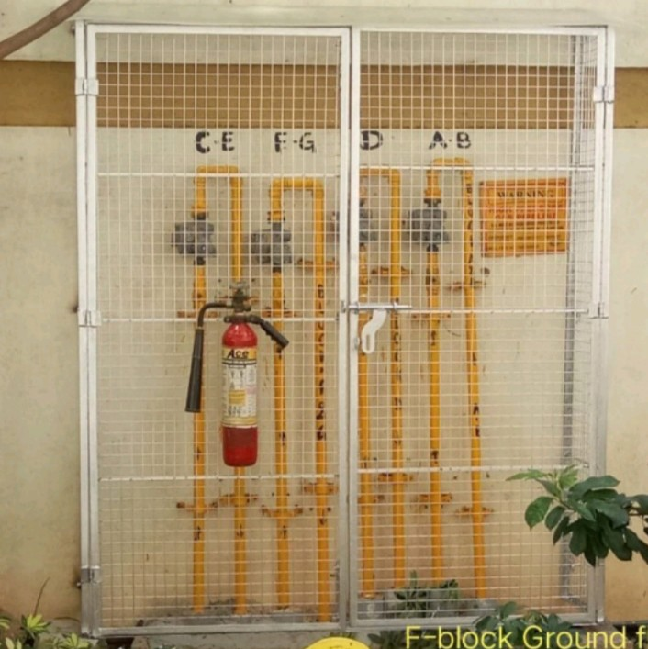
Thanks & Regards,
Tapan Shukla
GGL, Bangalore

From: Tapan Shukla (तपन शुक्ला) <tapan.shukla@gail.co.in>
Sent: Friday, February 13, 2026 09:04
To: BS, Nagendra <Nagendra.BS@jll.com>; president@sugruha.in <president@sugruha.in>; secretary@sugruha.in <secretary@sugruha.in>
Cc: Ravi Tandle (रवि तांडले) <ravi.tandle@gail.co.in>; rcm.bengaluru3@energyworld.biz <rcm.bengaluru3@energyworld.biz>; abhishek.resonance06@gmail.com <abhishek.resonance06@gmail.com>; descoinfra.blr@gmail.com <descoinfra.blr@gmail.com>; bhavardhanmv@gmail.com <bhavardhanmv@gmail.com>; South City MC <scmcee@gmail.com>; Ramani R <rsramani1957@gmail.com>; N, Mahesha <Mahesha.N@jll.com>; Sankannanavar, M <M.Sankannanavar@jll.com>; Pk, Harry <Harry.Pk@jll.com>; helpdesksouthcity <helpdesksouthcity@gmail.com>; Dharmendra Kumar (धर्मेंद्र कुमार) <dharmendra@gail.co.in>; SURENDRA BABU NAIK BANAVATHU (सुरेंद्र बाबू नाइक बनवथु) <surendrababu@gail.co.in>; bhavardhanmv@gmail.com <bhavardhanmv@gmail.com>; L Somasundaram (एल. सोमसुन्‍दरम) <lsomasundaram@gail.co.in>; Archit Gupta (अर्चित गुप्ता) <archit.gupta@gail.co.in>; Akash Kumar <akashkr00@outlook.com>; GGLBLR-HSR O&M <gglblrhsr@gail.co.in>
Subject: Re: Intimation regarding MDPE connectivity of L&T south city apartment & availability of PNG inside the apartment.
Dear Sir,
In line with trailing mail this is to bring into attention of all the concerned that entire MDPE (underground)pipe network laid inside L&T south city apartment has been charged & handed dover to GGL operations & maintenance team. In view of which it is requested to avoid digging/excavation related activities on/in vicinity of MDPE corridor, if unavoidable than written intimation must be given to concerned GGL authority well in advance & approval thereof must be obtained beforehand carrying out any such related activities.
In case of gas leak/emergency condition pls call at below mentioned helpline numbers:
9036004227
8904085010 (24*7)
8904085011(10 AM to 5 PM)
Toll-Free: 18001029282
Henceforth, commissioning of existing DPNG GI infrastructure related works shall be taken up to expedite commencement of PNG to individual towers. May contact below representatives for site coordination & related needful:
1)Mr. Satyam-9810882133, RCM(PMC)
Thanks & Regards,
Tapan Shukla
GGL, Bangalore

From: Tapan Shukla (तपन शुक्ला) <tapan.shukla@gail.co.in>
Sent: 07 February 2026 12:29
To: BS, Nagendra <Nagendra.BS@jll.com>; president@sugruha.in <president@sugruha.in>; secretary@sugruha.in <secretary@sugruha.in>
Cc: Ravi Tandle (रवि तांडले) <ravi.tandle@gail.co.in>; rcm.bengaluru3@energyworld.biz <rcm.bengaluru3@energyworld.biz>; abhishek.resonance06@gmail.com <abhishek.resonance06@gmail.com>; descoinfra.blr@gmail.com <descoinfra.blr@gmail.com>; bhavardhanmv@gmail.com <bhavardhanmv@gmail.com>; South City MC <scmcee@gmail.com>; Ramani R <rsramani1957@gmail.com>; N, Mahesha <Mahesha.N@jll.com>; Sankannanavar, M <M.Sankannanavar@jll.com>; Pk, Harry <Harry.Pk@jll.com>; helpdesksouthcity <helpdesksouthcity@gmail.com>; Dharmendra Kumar (धर्मेंद्र कुमार) <dharmendra@gail.co.in>; SURENDRA BABU NAIK BANAVATHU (सुरेंद्र बाबू नाइक बनवथु) <surendrababu@gail.co.in>; bhavardhanmv@gmail.com <bhavardhanmv@gmail.com>; L Somasundaram (एल. सोमसुन्‍दरम) <lsomasundaram@gail.co.in>; Archit Gupta (अर्चित गुप्ता) <archit.gupta@gail.co.in>; Akash Kumar <akashkr00@outlook.com>; GGLBLR-HSR O&M <gglblrhsr@gail.co.in>
Subject: Re: Intimation regarding MDPE connectivity of L&T south city apartment & availability of PNG inside the apartment.
Dear Sirs,
With reference to above cited subject this is for information to all the concerned that MDPE connectivity of L&T south city apartment has been completed & PNG gas is available inside the apartment till valve chamber location. In view of which it is requested to avoid digging/excavation related activities on/in vicinity of MDPE corridor, if unavoidable than written intimation must be given to concerned GGL authority well in advance & approval thereof must be obtained beforehand carrying out any such related activities.
In case of gas leak/emergency condition pls call at below mentioned helpline numbers:
9036004227
8904085010 (24*7)
8904085011(10 AM to 5 PM)
Toll-Free: 18001029282
Further, commissioning of existing DPNG infrastructure (MDPE & GI) related works shall be taken up. May contact below representatives for site coordination & related needful:
1)Mr. Satyam-9810882133, RCM(PMC)
Thanks & Regards,
Tapan Shukla
GGL, Bangalore

9. SIGNATURES & ACKNOWLEDGEMENT
By signing or acknowledging below, the parties agree to be bound by the terms and conditions of this Agreement.
CONTRACTOR
Name: Chinnaraju V
Mobile: +91 89712 21397
Aadhaar: 9412 2291 1997
UPI ID to which each Subscriber will make payment: 8971221397-2@ybl
Alternatively Bank account details:
Bank name -STATE BANK OF INDIA
NAME -CHINNARAJU V
IFSC -SBIN0040864
ACCOUNT NUMBER -64159904215

Signature: ___________________________
Date: 26/Feb/2026
GAIL GAS AUTHORIZED REPRESENTATIVE
Name: Nikunj
Designation: GAIL Gas Authorized Personnel
Signature: ___________________________
Date: 26/Feb/2026

PROPERTY MANAGEMENT REPRESENTATIVE
Name: Nagendra B S
Designation: Property Manager for South City
Signature: ___________________________
Date: ___________________________

SUBSCRIBERS signatures in attached sheets
With GAIL subscriber #, flat number, amount transferred (Rs 450), transaction reference, signature, date as per overleaf tables:

